Update Compensation Manager Quick Reference Guide Last Updated: 02/15/2023
Contents
Access SuccessFactors 1
Searching for an Employee 1
Updating Compensation Manager 1

Access SuccessFactors
Visit OneCampus and select Employee Launchpad.  Log in using Purdue Career Account ID and password. |  | https://one.purdue.edu/

Searching for an Employee
As the employee’s name is being typed, multiple matches will be displayed.  Scroll down to the correct employee’s name and click to select. | 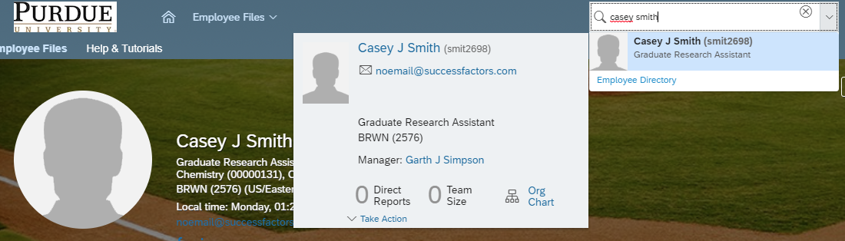
This will display the employee’s Employee File.  If employee holds concurrent positions, be sure to choose the correct position. | 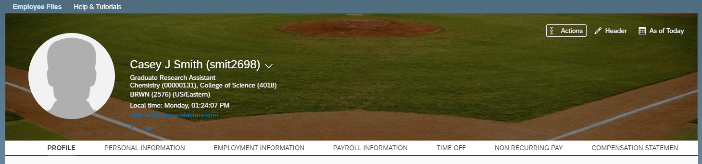

Updating Compensation Manager
Scroll down to the Job Relationships section.
Click on the pencil.
Choose today’s date
Remove the existing Compensation Manager’s name from the Name field. Begin typing the new Compensation Manager’s name in the name field and select the appropriate individual from the search list. If the new compensation manager has concurrent positions, be sure to choose the correct position.
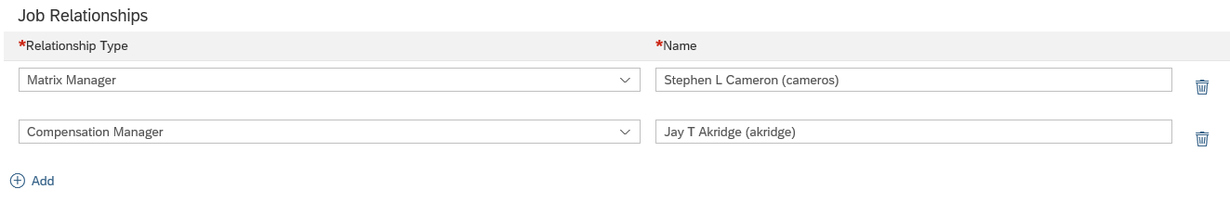

If employee does not currently have a compensation manager, click on Add
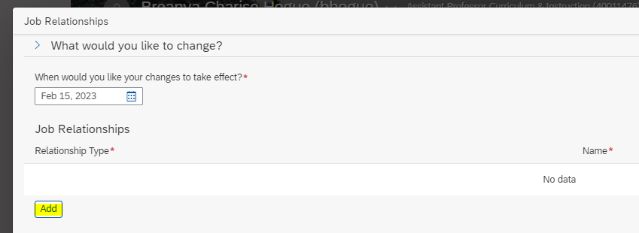

Then, choose Compensation Manager under Relationship Type
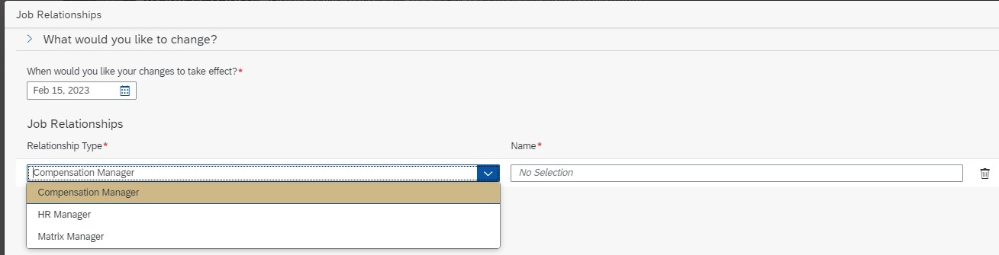

Begin typing the new Compensation Manager’s name in the name field and select the appropriate individual from the search list. If the new compensation manager has concurrent positions, be sure to choose the correct position.

